Part A: Read the sentences which have the following words in the text. Then match the words with the correct pictures. The words are bold and underlined in the text.
1. post box 5. island
2. enjoyable 6. prison
3. delicious 7. prisoner
4. ship 8. shine

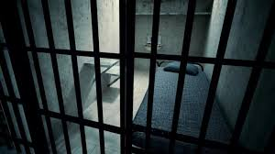  a. __ |   b. __
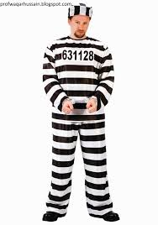  c. __ | 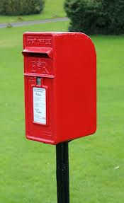  d. __
  e. __ | 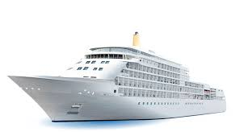  f. ___
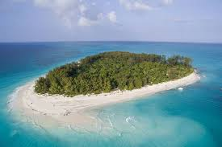  g._ |   h. __

SAN FRANCISCO
1 San Francisco is in the State of California. It is in the west of the United States. It is a very big city, but it is not the capital of California. Mostly Americans live in San Francisco, but there are also people from different countries. For example, there are many Austrians, Italians, and Chinese in San Francisco.
2 The Chinese live in Chinatown, so there are many Chinese restaurants there. The houses, post boxes and telephones in the streets are all in Chinese style. This part of the town is exactly like China. Tourists find Chinatown very interesting, and they visit it quite often.
3 Fisherman’s Wharf is another enjoyable place for tourists. You can find a table in a nice little restaurant near the sea and eat delicious sea food or sit in a nice cafe and listen to the street musicians. You can also watch the Golden Gate Bridge. It is the symbol of San Francisco. People enjoy watching the wonderful view of the ships.
4 After you finish your meal, you can take a boat trip to Alcatraz. It is on a small island and close to San Francisco. It is an old prison and there are no prisoners there now. Only tourists go there to visit it now.
5 San Francisco is different from other American cities. It is more European. In San Francisco, the sun always shines and winters are not so cold. There are a lot of things to do at nights. You can go to nightclubs, discos, restaurants and theatres, so a lot of young people want to live there.
Part B: Read the text and choose the correct option.
- San Francisco _____________________________.
- is in the northwest of California
- is the capital city of California
- is home to Americans only
- is a very large city

- Chinatown in San Francisco is similar to China because ______________________.
- it has a Chinese name
- there are a lot of tourists there
- Chinese visit there quite often
- the city is in Chinese style

- According to paragraph 3, ________________________________.
- the restaurants in Fisherman’s Wharf are very expensive
- you can listen to street musicians in Fisherman’s Wharf
- the Golden Gate Bridge is the symbol of Fisherman’s house
- you can go to Fisherman’s Wharf by ship

- Alcatraz ______________________________________.
- is far away from the center of San Francisco
- is a famous place for tourists
- is a prison for three hundred people
- is a famous antique theatre

- According to paragraph 5, _________________________.
- winters are long and cold in San Francisco
- San Francisco is a popular place among young people
- San Francisco is different from Europe
- it is always cloudy in San Francisco

- In Paragraph 5, “there” means ____________.
Fisherman’s House b. Europe c. San Francisco d. The Golden Gate Bridge

